

Lab Manual
Subject: Programming of AI

By
M. HassanTariq 2023-BS-AI-004
Semester 5th
Course Code AI-212
Supervised by Sir Samraiz
The University of Faisalabad
Bachelors of Science in Artificial Intelligence
DEPARTMENT OF COMPUTER SCIENCE

Table of Contents
Lab 1 3
Lab 2 15Lab 3 32
Lab 4 38

Lab Manual
Lab 1
Python Questions
Q1. Banking Transaction Validator with PIN
Output

Q2. Grocery Store Inventory System

Output
Q3. Student Grading with Subject Weightage
Output
Q4. BMI + Health Recommendation
Output
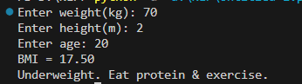
Q5. Telecom Prepaid Recharge System
Output

Q6. E-Commerce Discount Engine with Membership Levels
Output
Q7. Hospital Emergency Unit with Multi-Condition Triage
Output
Q8. Online Examination Grader with Negative Marking
Output
Q9. Movie Ticket Booking with Age & Timing Policy
Output
Q10. Weather-based Outfit + Travel Suggestion
Output
Q11. ATM Withdrawal with Note Counting + Receipt.
Output
Q12. Library Fine Calculator with Membership Levels
Output
Q13. Sales Analysis Dashboard

Output
Q14. Multiplication Puzzle with Random Blanks
Output

Q15. Password Strength + Re-entry Attempts
Output
Q16. Electricity Bill with Slabs & Penalty
Output

Q17. Cricket Match Predictor with Multiple Conditions
Output
Q18. Hotel Booking with Tax & Discount
Output
Q19. Flight Fare Calculator with International Tax
Output

Q20. Smart Vending Machine with Wallet System
Output

Lab 2
Python OOP Questions
Question # 1: Create a `BankAccount` class that represents a bank account. It should have attributes for account number, account holder name, and balance. Include methods to deposit, withdraw, and display balance. Ensure withdrawals cannot exceed the available balance.

Output

Question # 2: Design a `Book` class with attributes like title, author, ISBN, and availability status. Create a `Library` class that can add books, search for books by title/author, check out books, and return books. Track which books are currently available.
Output

Question # 3: Create a `Student` class with attributes for student ID, name, and a list of grades. Implement methods to add grades, calculate average grade, and determine the letter grade (A, B, C, etc.). Add a method to display student information with their performance summary.

Output

Question # 4: Design a `MenuItem` class for food items (name, price, category) and an `Order` class that can add multiple items, calculate total cost, apply discounts, and generate receipts. Include tax calculation functionality.

Output

Question # 5: Create classes for `Vehicle` (base class) and derived classes `Car`, `Motorcycle`, and `Truck`. Each vehicle should have attributes like license plate, model, rental price per day, and availability. Implement a system to rent vehicles and calculate rental costs.
Output

Question # 6: Design an `Employee` class with attributes for employee ID, name, position, and salary. Create methods to calculate monthly salary, annual salary, and apply raises. Include functionality to track employee details and employment duration.
Output
Question # 7: Create a `Product` class with attributes for product ID, name, price, and stock quantity. Design a `ShoppingCart` class that can add products, remove products, calculate total cost, and handle checkout process while updating inventory.

Output
Question # 8: Design a `Patient` class to store patient information (ID, name, age, medical history) and an `Appointment` class to manage doctor appointments. Include functionality to schedule, cancel, and view appointments.
Output
Question # 9: Create a `User` class for a social media platform with attributes for username, email, friends list, and posts. Implement methods to add friends, create posts, and display user timeline. Include privacy settings for posts.
Output

Question # 10: Design a `Room` class with room number, type (single/double/suite), price, and availability. Create a `Booking` class to handle room reservations, check-in/check-out dates, and calculate total stay cost.
Output

Lab 3
Numpy
Question 1: A weather station records temperatures (°C) for 7 days
Output

Question 2: A fruit store records daily sales of apples for 4 weeks

Output

Question 3: Students received marks in a test
Output
Question 4: A smartwatch stores daily step-counts for a user for 30 days.
Output
Question 5: Heart rate readings (in BPM) for 10 patients recorded 4 times per day
Output
Question 6: Two branches of a store record monthly sales (in thousands)
Output
Question 7: Given a 4×4 grayscale image
Output
Question 8: Dataset contains 100 samples with 4 features each.
Output
Question 9: Simulate traffic density (cars per minute) recorded by 6 sensors over 24 hours.
Output

Question 10: You are simulating forces in a mechanical system.
Output

Lab 4
Predictions

Q1. Patient Stay Analysis (Healthcare)
You are given a dataset containing age, disease_type, and hospital_stay_days.
Write a Python program using Seaborn to:
- Plot the distribution of hospital stay days
- Compare hospital stay across different disease types
- Identify which disease has the highest median stay
Code:
import pandas as pd
import seaborn as sns
import matplotlib.pyplot as plt

data = {
'age': [25, 40, 60, 35, 50, 70, 45, 55, 65, 30],
'disease_type': ['Flu', 'Covid', 'Cancer', 'Flu', 'Covid',
'Cancer', 'Flu', 'Covid', 'Cancer', 'Flu'],
'hospital_stay_days': [3, 10, 20, 4, 12, 25, 5, 9, 30, 2]
}

df = pd.DataFrame(data)
df

Output:
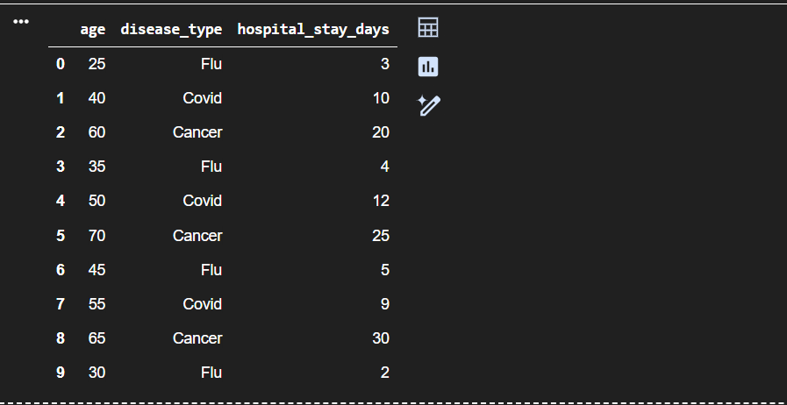

Code:
plt.figure(figsize=(8,5))
sns.histplot(df['hospital_stay_days'], kde=True)
plt.title("Distribution of Hospital Stay Days")
plt.xlabel("Hospital Stay Days")
plt.ylabel("Frequency")
plt.show()

Output:
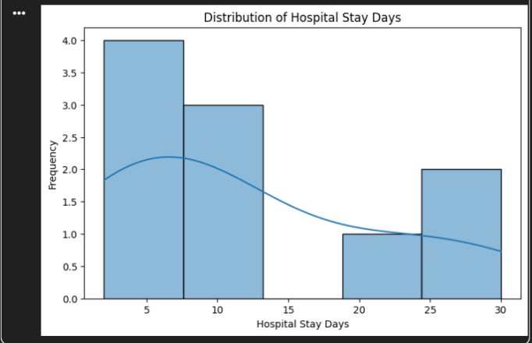
Code:
plt.figure(figsize=(8,5))
sns.boxplot(x='disease_type', y='hospital_stay_days', data=df)
plt.title("Hospital Stay by Disease Type")
plt.xlabel("Disease Type")
plt.ylabel("Hospital Stay Days")
plt.show()
Output:
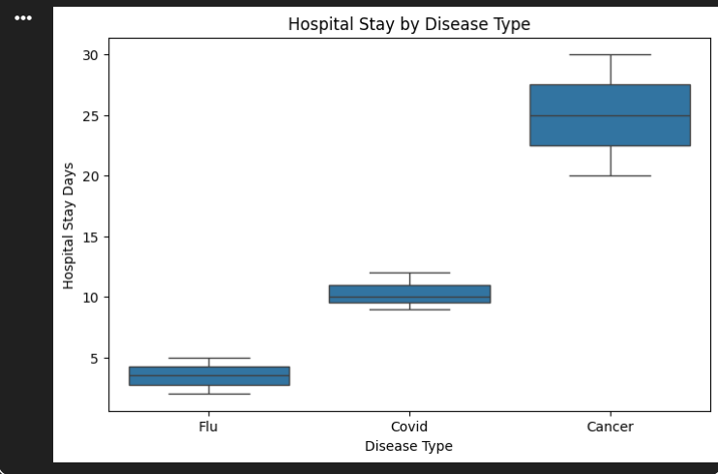

median_stay = df.groupby('disease_type')['hospital_stay_days'].median()
median_stay

Output:
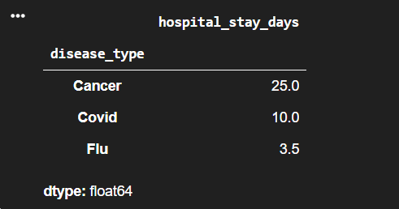
Code:
highest_median_disease = median_stay.idxmax()
print("Disease with highest median hospital stay:", highest_median_disease)

Output:
Q2. Sales Distribution Comparison (Business)
A retail dataset contains region and monthly_sales.
Write code to:
- Visualize sales distribution per region using Seaborn
- Detect regions with high sales variability
- Label the axes and add a title
Code:
data = {
'region': ['North', 'South', 'East', 'West',
'North', 'South', 'East', 'West',
'North', 'South', 'East', 'West'],
'monthly_sales': [20000, 15000, 18000, 22000,
25000, 14000, 17000, 26000,
30000, 16000, 19000, 28000]
}

df = pd.DataFrame(data)
df
Output:
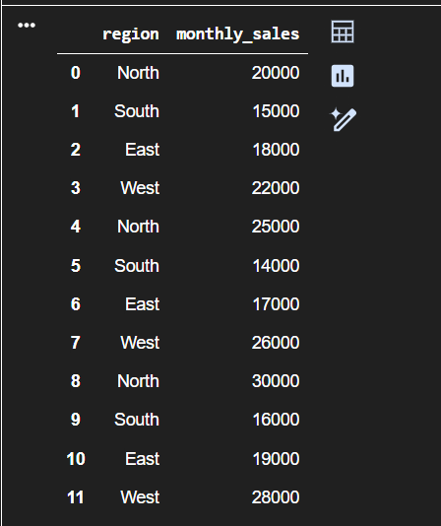
Code:
plt.figure(figsize=(8,5))
sns.boxplot(x='region', y='monthly_sales', data=df)
plt.title("Monthly Sales Distribution by Region")
plt.xlabel("Region")
plt.ylabel("Monthly Sales")
Output:
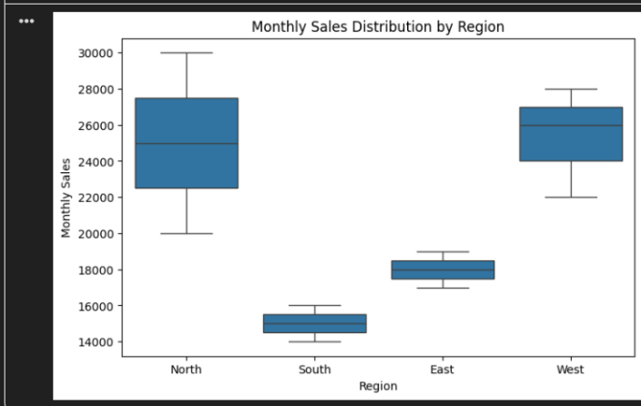
Code:
sales_variability = df.groupby('region')['monthly_sales'].std()
sales_variability
Output:
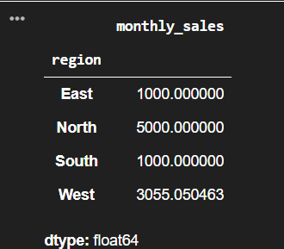

Code:
high_variability_region = sales_variability.idxmax()
print("Region with highest sales variability:", high_variability_region)

Output:
Q3. Student Performance Correlation (Education)
A dataset contains study_hours, attendance, and final_score .
Using Seaborn:
- Create a pair plot
- Plot a correlation heatmap
- Interpret which feature most affects the final score
Code:
data = {
'study_hours': [2, 4, 6, 8, 10, 12, 5, 7, 9, 11],
'attendance': [60, 65, 70, 80, 85, 90, 75, 78, 88, 92],
'final_score': [50, 55, 65, 75, 80, 90, 68, 72, 85, 92]
}

df = pd.DataFrame(data)
df
#Shows relationships between all features
sns.pairplot(df)
plt.show()
#Displays strength of relationships numerically
plt.figure(figsize=(6,5))
corr = df.corr()

sns.heatmap(corr, annot=True, cmap='coolwarm')
plt.title("Correlation Heatmap of Student Performance")
plt.show()
#Find strongest correlation with final_score
corr['final_score']

Output:
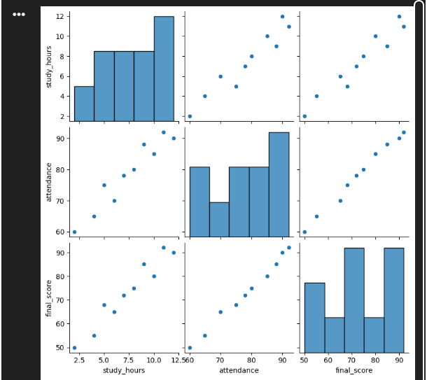
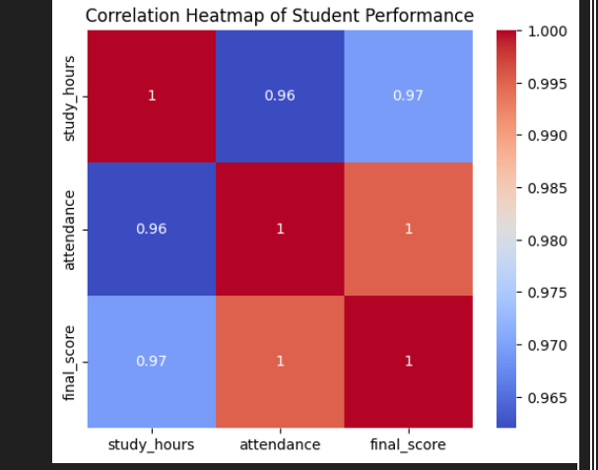
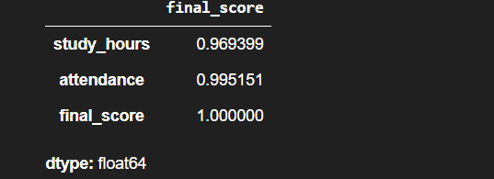
Q4. Customer Segmentation Visualization
Customer data includes age, annual_income, and spending_score.
Write a program to:
- Visualize relationships using Seaborn scatter plots
- Color-code points based on spending score
- Identify potential customer segments visually

Code:
import pandas as pd
import seaborn as sns
import matplotlib.pyplot as plt

# -------------------- Create Sample Customer Dataset --------------------
data = {
'age': [22, 25, 30, 35, 40, 45, 28, 33, 38, 42, 50, 55],
'annual_income': [20000, 25000, 40000, 45000, 60000, 65000,
42000, 48000, 58000, 62000, 70000, 75000],
'spending_score': [80, 85, 60, 55, 40, 35, 65, 58, 45, 42, 30, 25]
}

df = pd.DataFrame(data)

# -------------------- Scatter Plot: Age vs Annual Income --------------------
plt.figure(figsize=(8,5))
sns.scatterplot(
x='age',
y='annual_income',
hue='spending_score',
palette='viridis',
size='spending_score',
data=df
)

plt.title("Customer Segmentation Based on Age, Income & Spending Score")
plt.xlabel("Age")
plt.ylabel("Annual Income")
plt.legend(title="Spending Score")
plt.show()

# -------------------- Visual Interpretation --------------------
print("Visual Customer Segments Identified:")
print("1. Young customers with high spending score → Premium customers")
print("2. Middle-aged customers with moderate income & spending → Regular customers")
print("3. Older customers with high income but low spending → Potential targets for marketing")

Output:
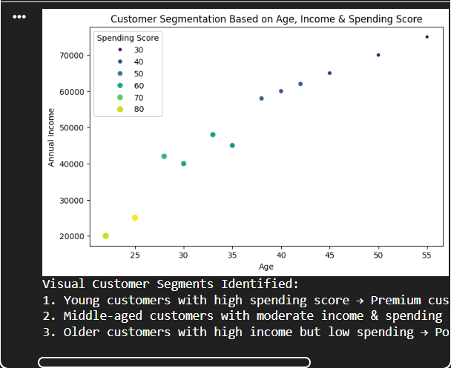
Q5. Model Result Visualization
You trained a classifier and obtained y_true and y_pred.
Write code using Seaborn to:
- Plot a confusion matrix heatmap
- Add annotations and color bar
- Clearly label predicted vs actual classes
Code:
from sklearn.metrics import confusion_matrix
y_true = [0, 1, 0, 1, 1, 0, 1, 0, 0, 1]
y_pred = [0, 1, 0, 0, 1, 0, 1, 1, 0, 1]
cm = confusion_matrix(y_true, y_pred)
plt.figure(figsize=(6,5))
sns.heatmap(
cm,
annot=True,
fmt='d',
cmap='Blues',
cbar=True
)
plt.title("Confusion Matrix")
plt.xlabel("Predicted Class")
plt.ylabel("Actual Class")
plt.show()

Output:
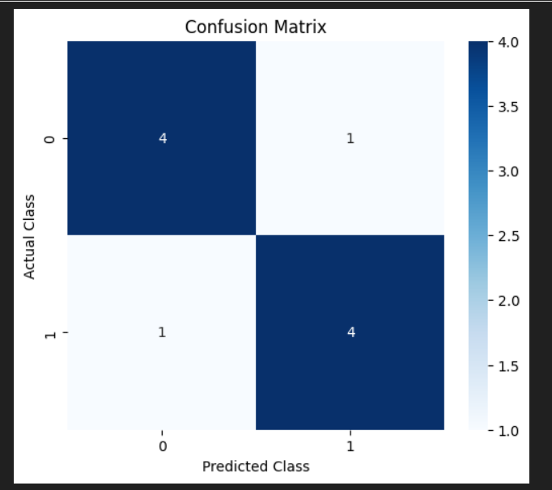
Q1. Telecom Customer Churn Prediction
Given customer data with features such as tenure, monthly_charges, and contract_type, and target churn.
Write a Scikit-learn program to:
- Encode categorical variables
- Train a Logistic Regression model
- Evaluate using accuracy and confusion matrix
Code:
import pandas as pd
from sklearn.model_selection import train_test_split
from sklearn.preprocessing import LabelEncoder
from sklearn.linear_model import LogisticRegression
from sklearn.metrics import accuracy_score, confusion_matrix
import seaborn as sns
import matplotlib.pyplot as plt
data = {
'tenure': [1, 5, 12, 24, 36, 6, 18, 30, 3, 48],
'monthly_charges': [70, 80, 65, 90, 100, 75, 85, 95, 60, 110],
'contract_type': ['Month-to-month', 'One year', 'Month-to-month',
'Two year', 'Two year', 'One year',
'Month-to-month', 'Two year', 'Month-to-month', 'Two year'],
'churn': ['Yes', 'No', 'Yes', 'No', 'No', 'No', 'Yes', 'No', 'Yes', 'No']
}
df = pd.DataFrame(data)
#Encode Categorical Variables
le = LabelEncoder()
df['contract_type'] = le.fit_transform(df['contract_type'])
df['churn'] = le.fit_transform(df['churn']) # Yes=1, No=0
#Split Features and Target
X = df[['tenure', 'monthly_charges', 'contract_type']]
y = df['churn']
X_train, X_test, y_train, y_test = train_test_split(
X, y, test_size=0.3, random_state=42
)
# Train Logistic Regression Model
model = LogisticRegression()
model.fit(X_train, y_train)
# Predictions
y_pred = model.predict(X_test)
# Evaluation
accuracy = accuracy_score(y_test, y_pred)
cm = confusion_matrix(y_test, y_pred)
print("Accuracy:", accuracy)
print("Confusion Matrix:\n", cm)
plt.figure(figsize=(5,4))
sns.heatmap(cm, annot=True, fmt='d', cmap='Blues')
plt.xlabel("Predicted")
plt.ylabel("Actual")
plt.title("Confusion Matrix - Churn Prediction")
plt.show()

Output:
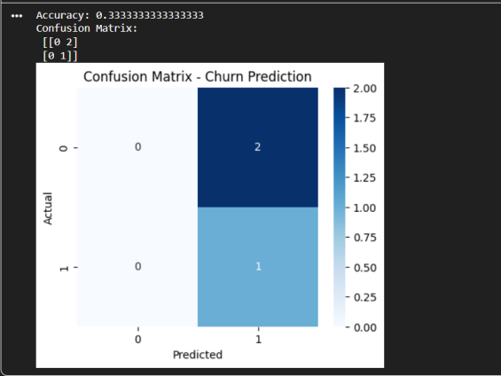
Q2. House Price Prediction
A dataset contains area, bedrooms, location_score, and price.
Implement a regression model to:
- Split data into train/test sets
- Train Linear Regression
- Predict prices and calculate Mean Squared Error

Code:
import pandas as pd
from sklearn.model_selection import train_test_split
from sklearn.linear_model import LinearRegression
from sklearn.metrics import mean_squared_error
# Ceate Sample House Dataset
data = {
'area': [800, 1000, 1200, 1500, 1800, 2000, 2200, 2500, 900, 1600],
'bedrooms': [2, 2, 3, 3, 4, 4, 4, 5, 2, 3],
'location_score': [6, 7, 8, 7, 9, 8, 9, 10, 6, 8],
'price': [50000, 65000, 80000, 90000, 120000, 130000, 140000, 160000, 60000, 95000]
}
df = pd.DataFrame(data)
# Split Features and Target
X = df[['area', 'bedrooms', 'location_score']]
y = df['price']

X_train, X_test, y_train, y_test = train_test_split(
X, y, test_size=0.3, random_state=42
)
# Train Linear Regression Model
model = LinearRegression()
model.fit(X_train, y_train)

# Predict House Prices
y_pred = model.predict(X_test)

# Calculate Mean Squared Error
mse = mean_squared_error(y_test, y_pred)

print("Mean Squared Error:", mse)

Output:
Q3. Disease Classification System
Patient data includes glucose, BMI, age, and outcome.
Write code to:
- Normalize the data
- Train a Decision Tree classifier
- Evaluate precision, recall, and F1-score
Code:
import pandas as pd
from sklearn.model_selection import train_test_split
from sklearn.preprocessing import StandardScaler
from sklearn.tree import DecisionTreeClassifier
from sklearn.metrics import precision_score, recall_score, f1_score
# Dataset
data = {
'glucose': [120, 85, 90, 140, 160, 110, 95, 180],
'BMI': [30.5, 24.0, 26.5, 32.1, 35.0, 28.4, 22.0, 36.2],
'age': [45, 30, 34, 50, 60, 42, 25, 65],
'outcome': [1, 0, 0, 1, 1, 0, 0, 1]
}
df = pd.DataFrame(data)

X = df[['glucose', 'BMI', 'age']]
y = df['outcome']

# Stratified Split (IMPORTANT FIX)
X_train, X_test, y_train, y_test = train_test_split(
X, y, test_size=0.25, random_state=42, stratify=y
)
# Normalization
scaler = StandardScaler()
X_train = scaler.fit_transform(X_train)
X_test = scaler.transform(X_test)

# Model
model = DecisionTreeClassifier(random_state=42)
model.fit(X_train, y_train)

# Prediction
y_pred = model.predict(X_test)

# Evaluation
print("Precision:", precision_score(y_test, y_pred))
print("Recall:", recall_score(y_test, y_pred))
print("F1-Score:", f1_score(y_test, y_pred))

Output:
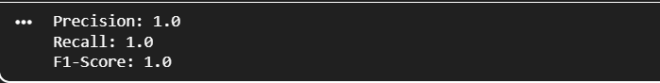
Q4. Email Spam Detection
You are given email text and spam labels.
Using Scikit-learn:
- Convert text to numerical features (TF-IDF)
- Train a Naive Bayes classifier
- Test the model on new email text

Code:
from sklearn.feature_extraction.text import TfidfVectorizer
from sklearn.naive_bayes import MultinomialNB
from sklearn.model_selection import train_test_split
from sklearn.metrics import accuracy_score
emails = [
"Win money now",
"Exclusive offer just for you",
"Meeting scheduled tomorrow",
"Project deadline extended",
"Claim your free prize",
"Let us discuss the report"
]

labels = [1, 1, 0, 0, 1, 0] # 1 = Spam, 0 = Not Spam

# Convert Text to Numerical Features (TF-IDF)
vectorizer = TfidfVectorizer()
X = vectorizer.fit_transform(emails)

y = labels

# Split Data
X_train, X_test, y_train, y_test = train_test_split(
X, y, test_size=0.3, random_state=42
)

# Train Naive Bayes Classifier
model = MultinomialNB()
model.fit(X_train, y_train)

# -------------------- Evaluate Model --------------------
y_pred = model.predict(X_test)
accuracy = accuracy_score(y_test, y_pred)

print("Model Accuracy:", accuracy)

# -------------------- Test Model on New Email --------------------
new_email = ["Congratulations! You have won a free gift"]
new_email_vector = vectorizer.transform(new_email)
prediction = model.predict(new_email_vector)

if prediction[0] == 1:
print("The email is SPAM")
else:
print("The email is NOT SPAM")

Output:

Q5. Student Risk Prediction
Student records include attendance, mid_marks, and final_marks.
Write a program to:
- Build a Random Forest classifier
- Predict whether a student is “At Risk”
- Display feature importance

Code:
# Student Risk Prediction using Random Forest Classifier
# Complete program (Google Colab ready)

import pandas as pd
from sklearn.model_selection import train_test_split
from sklearn.ensemble import RandomForestClassifier
from sklearn.metrics import accuracy_score
import matplotlib.pyplot as plt

# -------------------- Create Sample Student Dataset --------------------
data = {
'attendance': [60, 75, 90, 50, 85, 40, 70, 95, 55, 80],
'mid_marks': [40, 65, 80, 35, 75, 30, 60, 85, 45, 70],
'final_marks': [45, 70, 88, 40, 82, 35, 65, 92, 48, 78],
'at_risk': ['Yes', 'No', 'No', 'Yes', 'No', 'Yes', 'No', 'No', 'Yes', 'No']
}

df = pd.DataFrame(data)

# -------------------- Encode Target Variable --------------------
df['at_risk'] = df['at_risk'].map({'Yes': 1, 'No': 0})

# -------------------- Split Features and Target --------------------
X = df[['attendance', 'mid_marks', 'final_marks']]
y = df['at_risk']

X_train, X_test, y_train, y_test = train_test_split(
X, y, test_size=0.3, random_state=42
)

# -------------------- Train Random Forest Classifier --------------------
model = RandomForestClassifier(n_estimators=100, random_state=42)
model.fit(X_train, y_train)

# -------------------- Predict Student Risk --------------------
y_pred = model.predict(X_test)

accuracy = accuracy_score(y_test, y_pred)
print("Model Accuracy:", accuracy)

# -------------------- Feature Importance --------------------
feature_importance = pd.Series(
model.feature_importances_,
index=X.columns
).sort_values(ascending=False)

print("\nFeature Importance:")
print(feature_importance)

# -------------------- Plot Feature Importance --------------------
plt.figure(figsize=(6,4))
feature_importance.plot(kind='bar')
plt.title("Feature Importance - Student Risk Prediction")
plt.xlabel("Features")
plt.ylabel("Importance Score")
plt.show()

Output:
